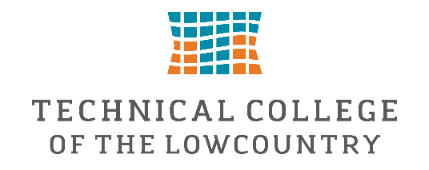

Federal Work-Study Job Description—Business & Student Services Marketing Assistant
The Business & Student Services Marketing Assistant provides administrative support to the Business & Industrial Technologies Department while assisting Student Services with the development of digital marketing and communication materials. This position offers students the opportunity to gain experience in office administration, digital content creation, graphic design, and professional communication.
The student will assist with routine office operations within the Business & Industrial Technologies Department while creating promotional materials that support Student Services initiatives, programs, events, and resources. Responsibilities may include designing graphics for digital signage, social media, campus television screens, and other student-facing communication channels, ensuring information is engaging, accurate, and aligned with the college's branding standards.

Essential Duties and Responsibilities

Administrative Support
- Assist with general office operations and departmental projects.
- Perform filing, scanning, copying, data entry, and document organization.
- Maintain departmental records and assist with office correspondence.
- Provide support for special projects and events as assigned.
- Assist staff with preparing materials for meetings, workshops, and presentations.
- Help organize and distribute informational materials for students and community partners.

Digital Marketing & Content Creation
- Design digital advertisements, flyers, graphics, and announcements for campus-wide display.
- Create content for digital signage displayed throughout TCL campuses.
- Update and manage content shown on television screens in Buildings 8 and 12 on the Beaufort Campus and within The HUB at the New River Campus.
- Assist with the expansion of digital signage communications to additional campus locations.
- Ensure marketing materials align with TCL branding and communication standards.
- Coordinate with departments to gather information and promote upcoming activities and initiatives.

Campus Communications & Promotions
- Create promotional materials for:
  - FAFSA completion campaigns
  - Financial Aid events and deadlines
  - Registration periods
  - Advising campaigns
  - Student success initiatives
  - Career Services programs
  - Federal Work-Study opportunities
  - Student engagement activities
  - Graduation and commencement information
  - Scholarship opportunities
  - Orientation and Welcome Week activities
  - Holiday and seasonal campus events

Campus-Wide Collaboration
- Work with departments including Financial Aid, Advising, Admissions, Career Services, and Student Engagement.
- Receive and post department-created flyers and announcements to campus digital displays.
- Assist departments in developing marketing materials when requested.
- Help ensure campus communications are current, accurate, and engaging.

Preferred Qualifications
- Strong written and verbal communication skills.
- Basic knowledge of Microsoft Office applications.
- Experience with Canva, Adobe Creative Suite, video editing software, or graphic design tools preferred.
- Ability to work independently and manage multiple projects.
- Strong attention to detail and organizational skills.
- Creativity and willingness to learn new marketing and communication techniques.
- Professional demeanor and ability to work collaboratively with faculty, staff, and students.
This Federal Work Study position will pay $15.00 per hour and is approved to work a maximum of 10 hours per week.
If you are interested in applying for this position, please complete the Federal Work Study Application.
Supervisor: Alysha Kromm
Email: akromm@tcl.edu

