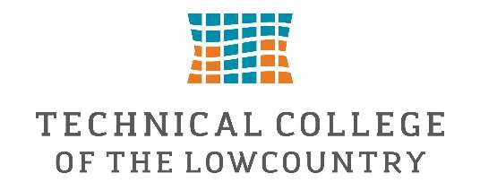

Federal Work-Study Job Description-Military & Veterans Programs
Department

Military & Veterans Programs (Military & Veterans Resource Center – MAVRC)

Position Summary

The Federal Work-Study Student Assistant provides administrative, customer service, and event support forthe Military & Veterans Programs Department. This position assists department staff with daily officeoperations while providing excellent customer service to military-connected students, veterans, active-dutyservice members, their dependents, and all visitors to the Military & Veterans Resource Center. The studentemployee will gain valuable experience in office administration, communication, organization, and highereducation student services while contributing to a welcoming, supportive, and inclusive campusenvironment.

Essential Job Duties

Welcome and assist students, visitors, faculty, staff, and community members entering the MAVRC.

Foster a welcoming and inclusive environment for all students, with particular attention to military-affiliated students, veterans, service members, and their families.

Answer telephone calls, respond to general inquiries, and direct individuals to the appropriate staffmember.

Assist with general office duties including filing, copying, scanning, data entry, mail distribution, anddocument preparation.

Maintain the organization, cleanliness, and professional appearance of the Military & VeteransResource Center.

Assist with inventory, office supply organization, and departmental projects.

Prepare informational packets, promotional materials, and outreach resources for students anddepartment events.

Assist with planning, setup, execution, and cleanup of Military & Veterans Programs events,workshops, orientations, and student activities.

Provide basic information regarding department services while referring benefit-specific questionsto School Certifying Officials or other appropriate staff.

Maintain confidentiality of student records in accordance with FERPA and departmental policies.

Perform other duties as assigned that support the mission of the Military & Veterans ProgramsDepartment.

2

Minimum Qualifications

Must be eligible for Federal Work-Study employment through the Technical College of theLowcountry Financial Aid Office.

Strong customer service and interpersonal communication skills.

Dependable with excellent attendance and punctuality.

Ability to maintain confidentiality and professionalism.

Basic computer skills, including Microsoft Office (Word, Excel, and Outlook), and the ability to learncollege software systems.

Strong organizational skills and attention to detail.

Ability to work independently and as part of a team.

Preferred Qualifications

Previous customer service or office experience.

Interest in serving military-connected students and veterans.

Experience working in a professional office environment.

Work Location

Military & Veterans Resource Center (MAVRC)Technical College of the Lowcountry

Work Schedule

Department operating hours: Monday–Thursday, 8:00 a.m. – 5:00 p.m.

Student work schedules will be arranged around class schedules and departmental needs.

Weekly hours will be determined by the student's Federal Work-Study award and departmentalbudget.

Supervisor

Marie HooperAssistant Director of Military & Veterans Programs / Primary School Certifying Official

The supervisor is responsible for:

Scheduling student work hours.

Providing orientation, training, and daily supervision.

Assigning and evaluating work performance.

Reviewing and approving student timesheets.

Serving as the primary departmental contact with the Financial Aid Office regarding all Federal Work-Study employment matters.

3

Learning Outcomes

Students employed in this position will have the opportunity to:

Develop professional customer service and interpersonal communication skills in a higher educationsetting.

Gain hands-on experience in office administration, student services, and event coordination.

Strengthen organizational, time management, problem-solving, and multitasking abilities.

Learn the importance of confidentiality, professionalism, and ethical responsibility when workingwith student information.

Build confidence working with diverse populations while supporting military-connected students,veterans, and their families.

Develop transferable workplace skills including teamwork, adaptability, accountability, and initiativethat will support future academic and career success.

