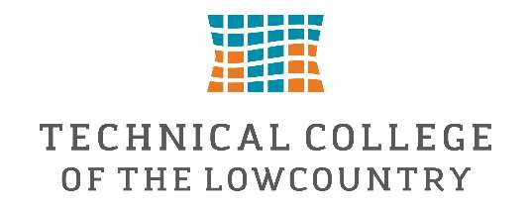

Federal Work-Study Job Description-Military & Veterans Programs

Department
- Military & Veterans Programs (Military & Veterans Resource Center – MAVRC)

Position Summary
The Federal Work-Study Student Assistant provides administrative, customer service, and event support for the Military & Veterans Programs Department. This position assists department staff with daily office operations while providing excellent customer service to military-connected students, veterans, active-duty service members, their dependents, and all visitors to the Military & Veterans Resource Center. The student employee will gain valuable experience in office administration, communication, organization, and higher education student services while contributing to a welcoming, supportive, and inclusive campus environment.

Essential Job Duties
- Welcome and assist students, visitors, faculty, staff, and community members entering the MAVRC.
- Foster a welcoming and inclusive environment for all students, with particular attention to military-affiliated students, veterans, service members, and their families.
- Answer telephone calls, respond to general inquiries, and direct individuals to the appropriate staffmember.
- Assist with general office duties including filing, copying, scanning, data entry, mail distribution, anddocument preparation.
- Maintain the organization, cleanliness, and professional appearance of the Military & VeteransResource Center.
- Assist with inventory, office supply organization, and departmental projects.
- Prepare informational packets, promotional materials, and outreach resources for students anddepartment events.
- Assist with planning, setup, execution, and cleanup of Military & Veterans Programs events,workshops, orientations, and student activities.
- Provide basic information regarding department services while referring benefit-specific questionsto School Certifying Officials or other appropriate staff.
- Maintain confidentiality of student records in accordance with FERPA and departmental policies.
- Perform other duties as assigned that support the mission of the Military & Veterans ProgramsDepartment.

Minimum Qualifications
- Must be eligible for Federal Work-Study employment through the Technical College of theLowcountry Financial Aid Office.
- Strong customer service and interpersonal communication skills.
- Dependable with excellent attendance and punctuality.
- Ability to maintain confidentiality and professionalism.
- Basic computer skills, including Microsoft Office (Word, Excel, and Outlook), and the ability to learncollege software systems.
- Strong organizational skills and attention to detail.
- Ability to work independently and as part of a team.

Preferred Qualifications
- Previous customer service or office experience.
- Interest in serving military-connected students and veterans.
- Experience working in a professional office environment.

Work Location
Military & Veterans Resource Center (MAVRC)
Technical College of the Lowcountry

Work Schedule
Department operating hours:
- Monday–Thursday, 8:00 a.m. – 5:00 p.m.
- Student work schedules will be arranged around class schedules and departmental needs.
- Weekly hours will be determined by the student's Federal Work-Study award and departmentalbudget.

Supervisor
Marie Hooper
Assistant Director of Military & Veterans Programs / Primary School Certifying Official
The supervisor is responsible for:
- Scheduling student work hours.
- Providing orientation, training, and daily supervision.
- Assigning and evaluating work performance.
- Reviewing and approving student timesheets.
- Serving as the primary departmental contact with the Financial Aid Office regarding all Federal Work-Study employment matters.

Learning Outcomes
Students employed in this position will have the opportunity to:
- Develop professional customer service and interpersonal communication skills in a higher educationsetting.
- Gain hands-on experience in office administration, student services, and event coordination.
- Strengthen organizational, time management, problem-solving, and multitasking abilities.
- Learn the importance of confidentiality, professionalism, and ethical responsibility when workingwith student information.
- Build confidence working with diverse populations while supporting military-connected students,veterans, and their families.
- Develop transferable workplace skills including teamwork, adaptability, accountability, and initiativethat will support future academic and career success.

