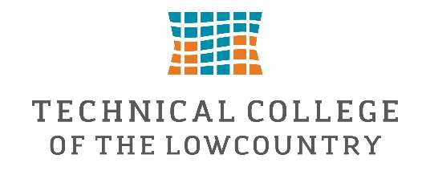

Federal Work-Study Job Description-Student Library Technician-Beaufort Mather Campus
Under general supervision, the Student Library Technician assists with general library functions on the Beaufort Mather Campus

Job Duties:

- Cover the library circulation desk, checking materials in and out to patrons. Answer basic directional and technology questions and refers questions to librarians, TCL help desk, and other college personnel as appropriate.
- Shelve books and assists with tasks related to collection maintenance, such as shelf reading, inventory, and shifting of collection.
- Assist in the processing of new books and other materials, including application of book jackets, barcodes, spine labels, etc.
- Assist in the review and editing of the library’s online instructional resources, such as tutorials, videos, and LibGuides.
- Check library book drop and mailbox. Perform all other related duties as may be assigned.

Special Skills Required:
- Excellent customer service skills
- Ability to learn & navigate online computer systems
- Ability to communicate well, both orally and in writing
- Ability to perform detailed work and multiple tasks
- Punctual and dependable
For more detailed information about what a library technician does you can visit our Library Work Study Training Guide.

This Federal Work Study position will pay $15.00 per hour and is approved to work a maximum of 20 hours per week.

If you are interested in applying for this position, please complete the Federal Work Study Application.
Supervisor: Rachel Murray
Email: rmurray@tcl.edu

