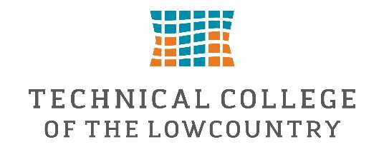

Federal Work Study Position Description-Institutional Advancement/Marketing & PR/Continuing Education/TCL Foundation
The Federal Work Study Intern will provide administrative and project-based support to the Institutional Advancement division including the TCL Foundation, Marketing/PR, and Continuing Education departments, at a higher education institution. This role is designed to assist with a variety of office functions and outreach efforts while offering the intern a professional development opportunity in a higher education setting.
Assist with front desk reception, data entry, filing, and document preparation. Support event planning, donor stewardship, and community outreach initiatives. Help prepare promotional materials and communications. Provide general administrative support.

Skills & Qualifications:
- Proficiency in Microsoft Office
- Professionalism
- Confidentiality and Discretion

Department:
Institutional Advancement Division; Marketing and PR, Continuing Education & TCL Foundation

Location:
Coleman Hall, Bldg 2: First Floor
This Federal Work Study position will pay $15.00 per hour and is approved to work a maximum of 15 hours per week.
If you are interested in applying for this position, please complete the Federal Work Study Application.
Supervisor:
Jessica Bridges
jbridges@tcl.edu
843.525.8294

